CAB203 Graphs Project

Joshua Wlodarczyk: N11275561

Date:

Tournament Structure:

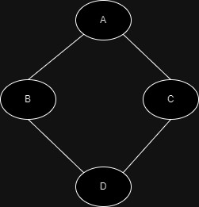

A, B, C, D = player1, player2, player3, player4

Neighbours: NG (u) = {v ∈ V : (u, v ) ∈ E

Degrees: 2|E | = ∑ d(u)  
 u∈V

Potential referees:

Assign referees:

Games schedule:

Player ranking:

References:

Notes:  
Q1: Neighbours, Degrees, Neighbour Sets (to find if they share opponents?)

Redo working out use the equations in how you worked it out but when mathematically showing it create your own based on the question.

Show dot points in a mathematical equation.

Evey player needs to play against or they need 2 games

Q2:

Q3: Spanning Path, Neighbour Set

Q4: TopOrdering, Find path, ShortestPath

Q5: Flow control